Raspberry Pi Setup

1. Setting up raspberry pi for the first time using USB OS.
2. Download the following softwares :
   1. Advanced IP Scannerd
   2. Mobaxterm
   3. Win32diskimager
3. Install OS from Raspberrypi.org : Use raspberian OS. Download the software ( .img ) file and use Win32diskimage and write the .img in the USB drive .
4. Go to config.txt , set at the beginning and save the file:

program_usb_boot_mode=1

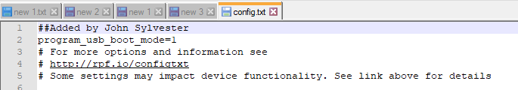

1. Go to the F:\ Drive ( USB Drive ) and give the echo > ssh in order to enable ssh in raspberry :

F:\> echo > ssh

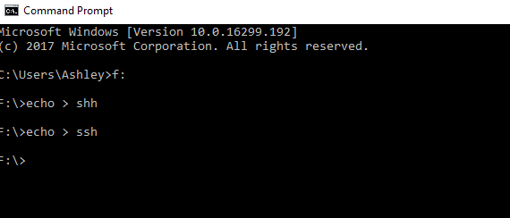

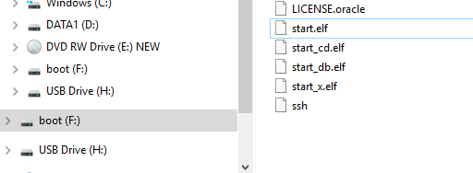

1. Go to Control Panel\ Network and Internet\ Network Connections :

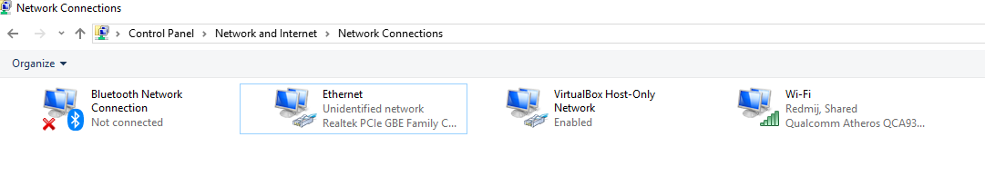

1. Select Ethernet connections , select IPV4 and set the properties

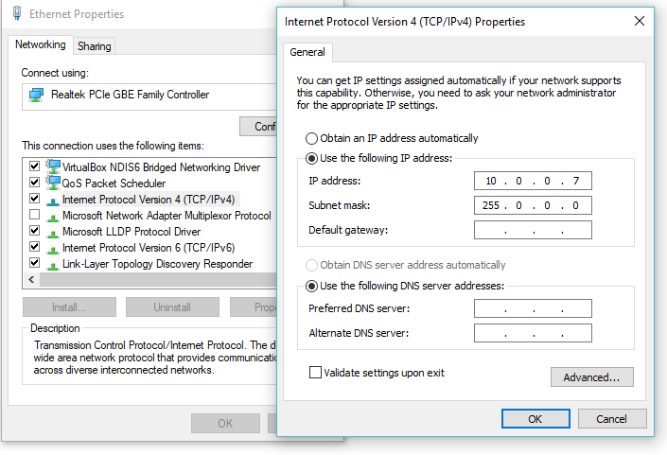

Static IP set is 10.0.0.7 in Ethernet Connections.

1. Go to cmdline.txt in F:\

At the end of the file, cmdline.txt , give a space and set :

ip=10.0.0.6 and save it.

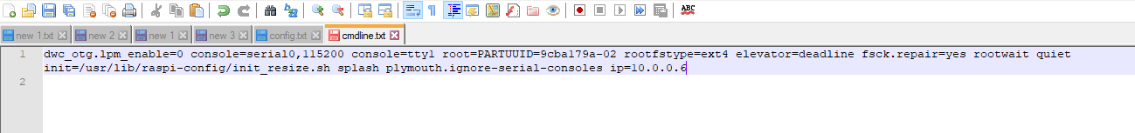

1. Connect the Raspberry Pi as shown below :

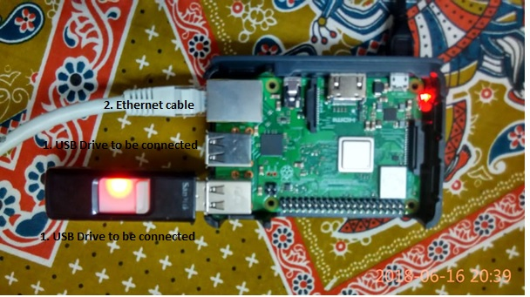

1. USB drive to usb port of raspberry pi
2. Connect Ethernet cable to the computer
3. Connect mini USB port to the power source.
4. Connect to Mobaxterm as follows 10.0.0.6 ( Note that Port is set in cmdline.txt ) : 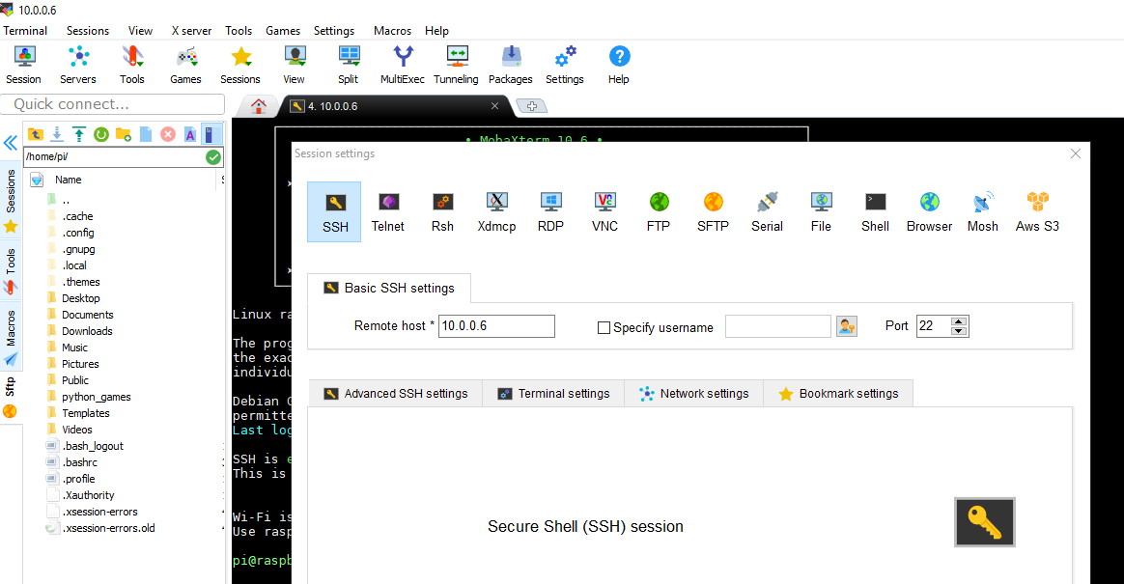
5. Login to 10.0.0.6 :

User id : pi

Password : raspberry

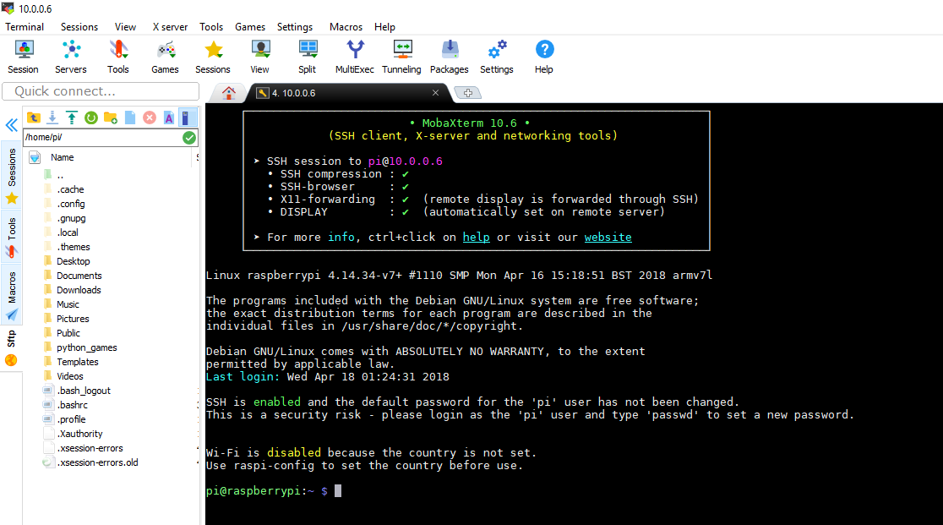

1. Password change :

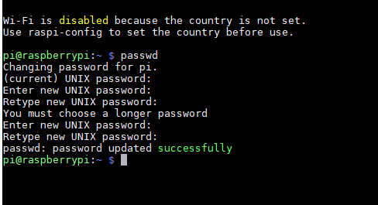

passwd is : john!john

Command for BIOS like setup : configure WIFI , enable UI at boot.

sudo raspi-config

Go to Boot option🡪 Desktop with ui login

Go to Networking Option 🡪 Network Option 🡪 Wifi

Redmij / zxcasdqwe123

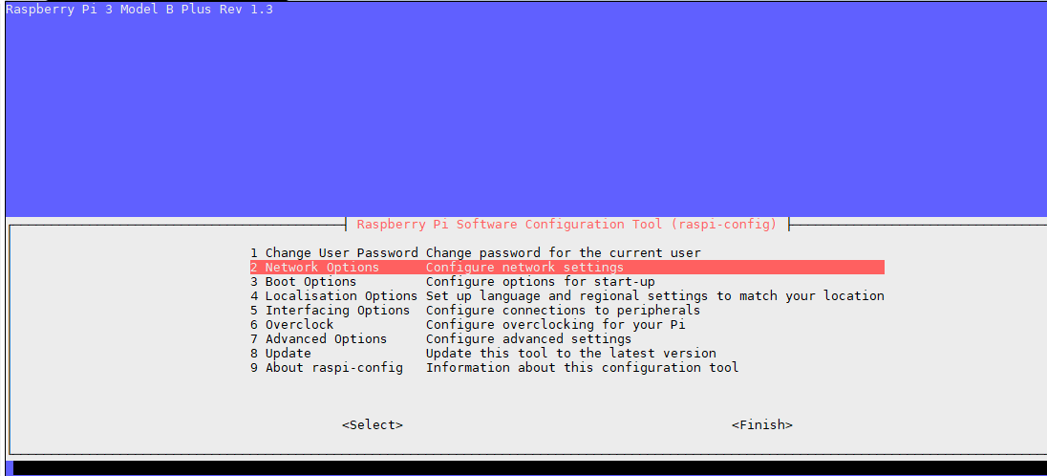

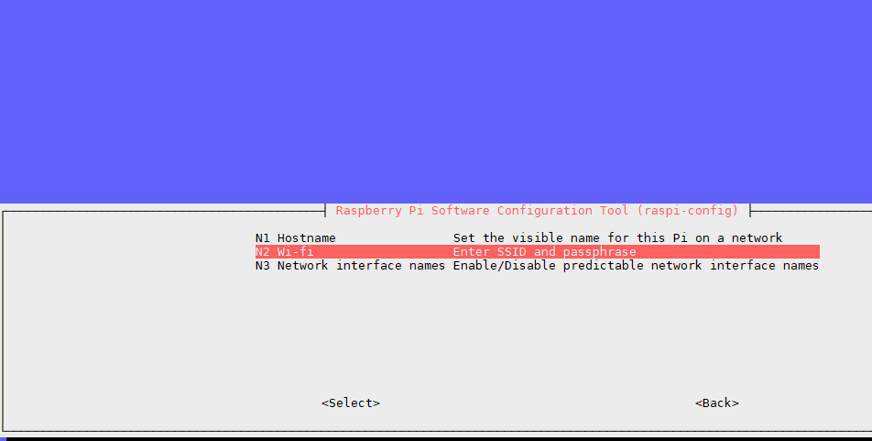

sudo shutdown -h now

sudo reboot

<https://www.elecrow.com/wiki/index.php?title=HDMI_Interface_5_Inch_800x480_TFT_Display>

**LCD setup :**

**Step1: Modify your config.txt file**  
  
**Tips:** [If you use SSH to control Pi](https://www.raspberrypi.org/documentation/remote-access/ssh/),please skip this step.

Insert the SD card to your Windows/Mac PC. Find the config.txt in the SD`s root and open it. Then add the following code in the end.

# --- added by elecrow-pitft-setup ---

hdmi_force_hotplug=1

max_usb_current=1

hdmi_drive=1

hdmi_group=2

hdmi_mode=1

hdmi_mode=87

hdmi_cvt 800 480 60 6 0 0 0

dtoverlay=ads7846,cs=1,penirq=25,penirq_pull=2,speed=50000,keep_vref_on=0,swapxy=0,pmax=255,xohms=150,xmin=200,xmax=3900,ymin=200,ymax=3900

display_rotate=0

# --- end elecrow-pitft-setup ---

git clone <https://github.com/Elecrow-keen/Elecrow-LCD5.git>

cd Elecrow-LCD5

sudo ./Elecrow-LCD5

sudo apt-get install -y xinput-calibrator

/etc/X11/xorg.conf.d/99-calibration.conf

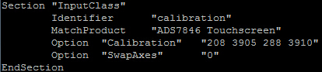

1. Setting up raspberry pi for the first time using USB OS and 5 inch screen.

Once all the setup in step I is complete, monitor can be connected and tested.

1. Connect the HDMI cable and the USB cable to Monitor

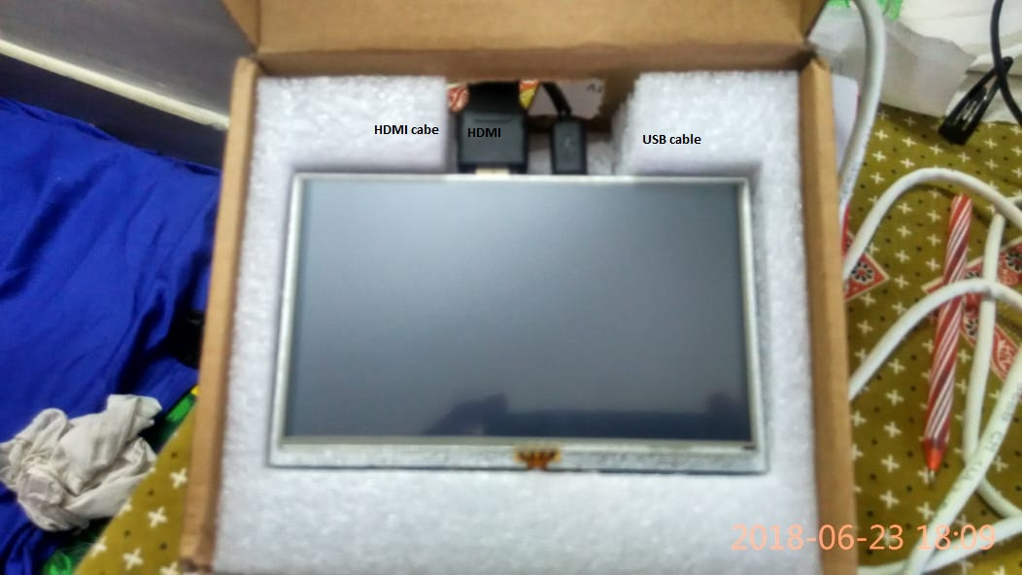

1. Connect other end of the the HDMI cable and the USB cable of Monitor to Raspberry Pi

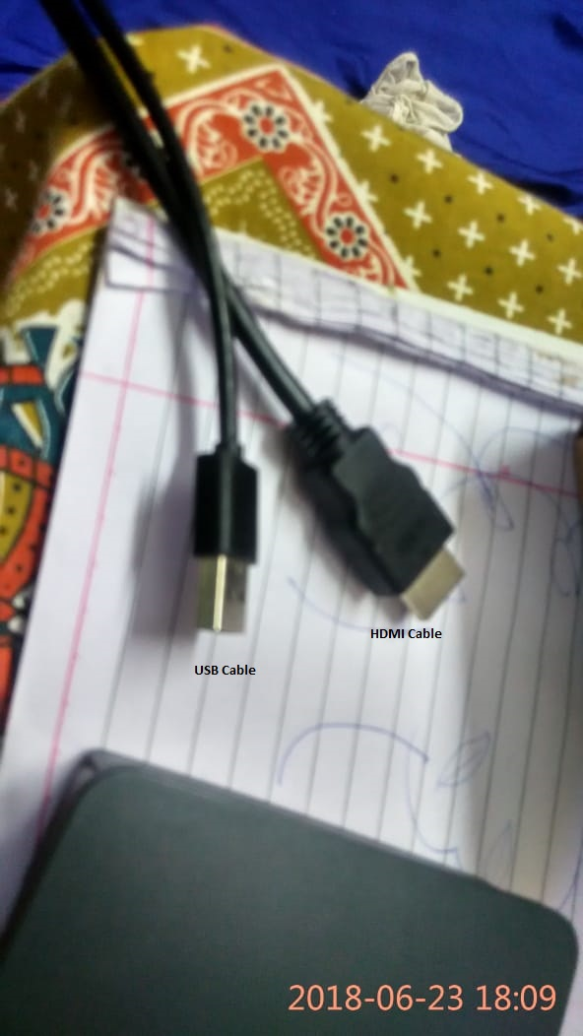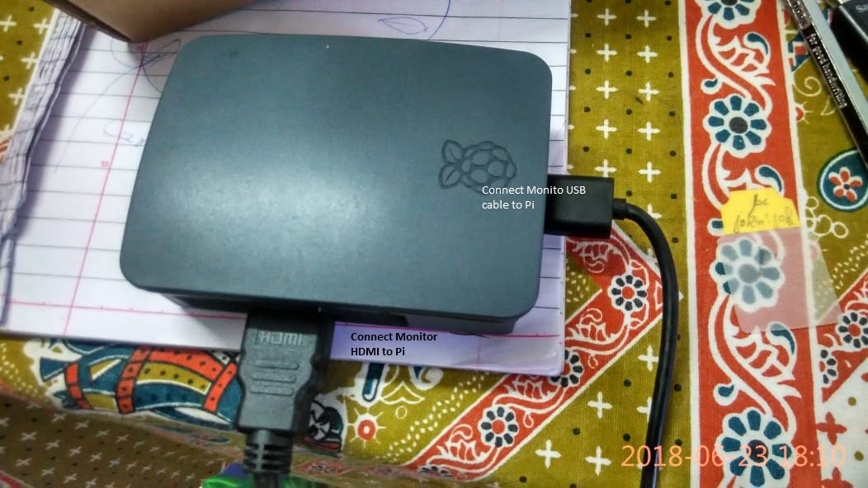

1. Connect Raspberry Pi’s USB OS as shown below

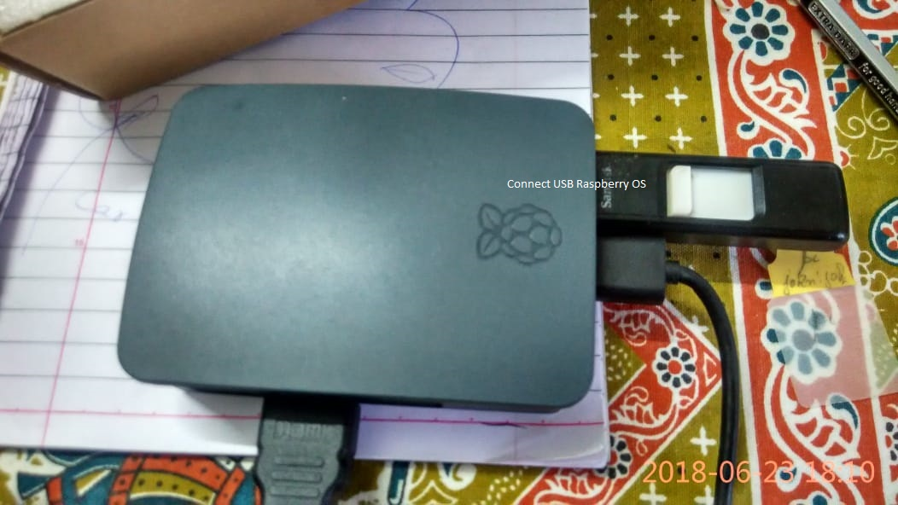

1. Connect Raspberry Pi to Keyboard , mouse and finally power the Raspberry PI through USB cable.

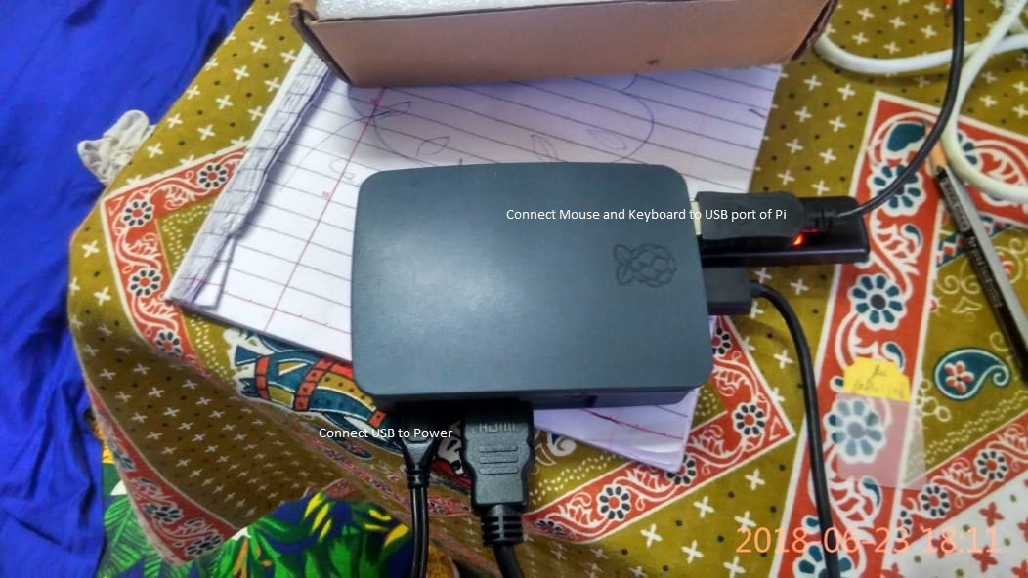

1. Raspberry Pi booting up:

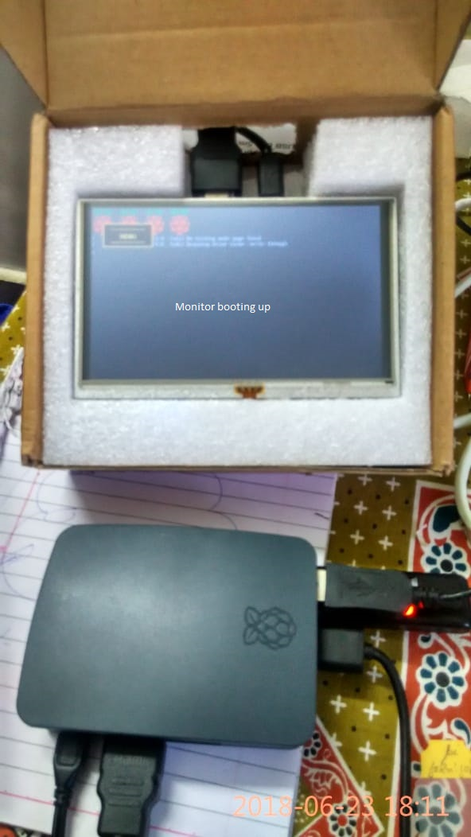

1. Login to Raspberry Pi using the user id / password configured in Step I:

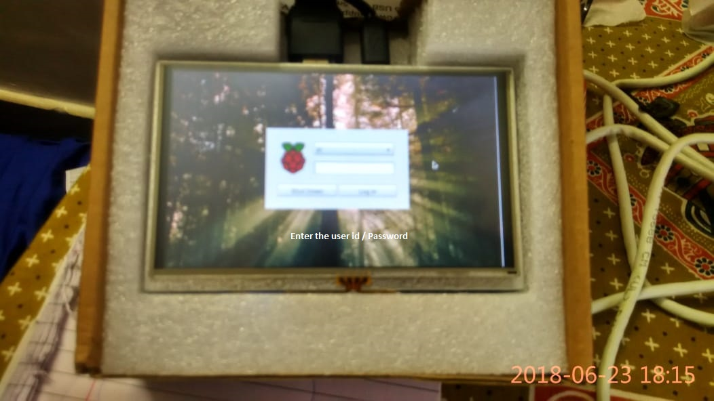

Since Raspberry PI is setup for WIFI Connection using “sudo raspi-config” in Step I, connecting to internet should not be problem.

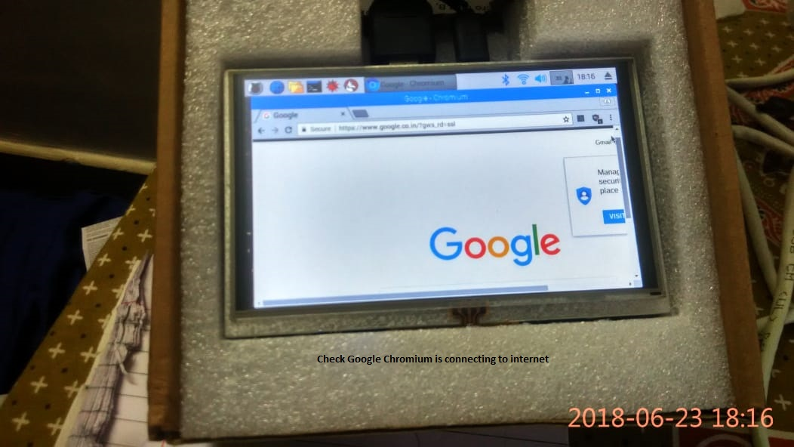

1. Accessing raspberry pi Desktop using Windows Computer
2. Connect to Raspberry Pi using MobaXterm

Enter the following commands :

sudo apt-get update

sudo apt-get upgrade

### **ENABLING VNC SERVER AT THE COMMAND LINE**

You can enable VNC Server at the command line using [raspi-config](https://www.raspberrypi.org/documentation/configuration/raspi-config.md):

sudo raspi-config

Now, enable VNC Server by doing the following:

* Navigate to **Interfacing Options**.
* Scroll down and select **VNC > Yes**.

1. Connect to Raspberry Pi using MobaXterm

Install VNC Viewer from Real VNC.

Connect using IP : 10.0.0.6

User id : pi

Password : john!john.

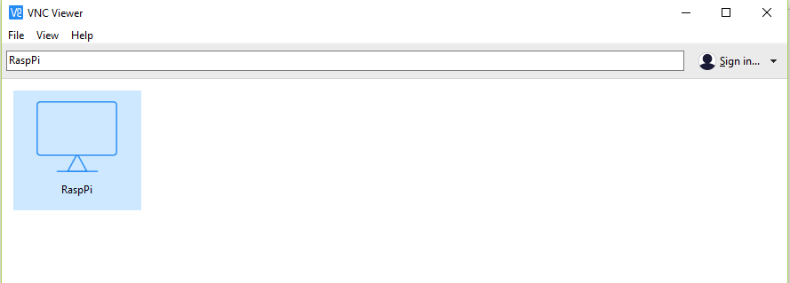

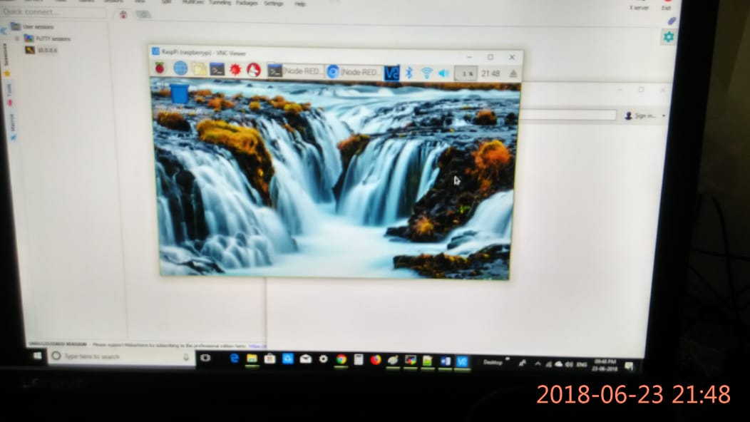

**Appendix Commands:**

sudo apt-get update

sudo apt-get upgrade

Tried out commands

**Following steps are NOT required :**

sudo apt-get install tightvncserver

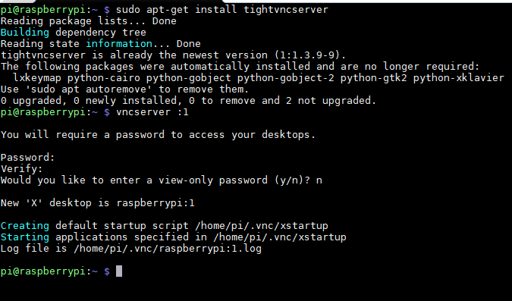

Password ( only 8 characters allowed ): john!joh

vncserver :1

sudo nano /etc/rc.local

Ctrl X to exit , give Y to save and enter.

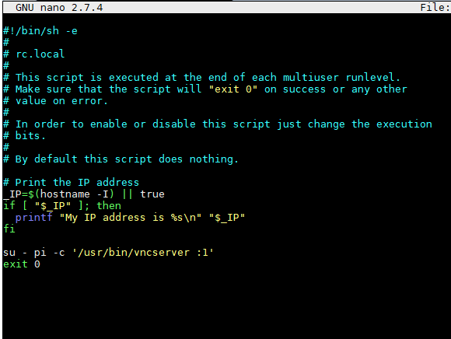

Sudo reboot